**Respiration as a life process**

* Respiration = Breathing + Cellular respiration
* Breathing (respiration) is the biological process of exchange of O2 from the atmosphere with CO2 produced by the cells.
* Breathing = Inhalation/inspiration + Exhalation/Expiration
* Cellular respiration

C6 H12O6 + O2 →   Energy + CO2 +  H2O

 Glucose                       (Harmful)

Breaking down of glucose (simple biomolecules) inside mitochondria of cells to generate energy in the form of ATP (Adenosine triphosphate).

**Different modes of respiration in animals**



**Table Comparison between aerobic respiration and anaerobic respiration**



**Respiration in plants**

* **Respiration in plants is much simpler than respiration in animals.**
* **Plants exchange respiratory gases through;**
  1. **Stomata in the surfaces of leaves**
  2. **Lenticels in stems**
  3. **Root hair cells**

**Human respiratory system**

**Primary function of respiratory system:** To obtain Oxygen (O2) for use by cells and elimination of Carbon dioxide (CO2) that cells produce.

**Figure Diagrammatic view of human respiratory system**

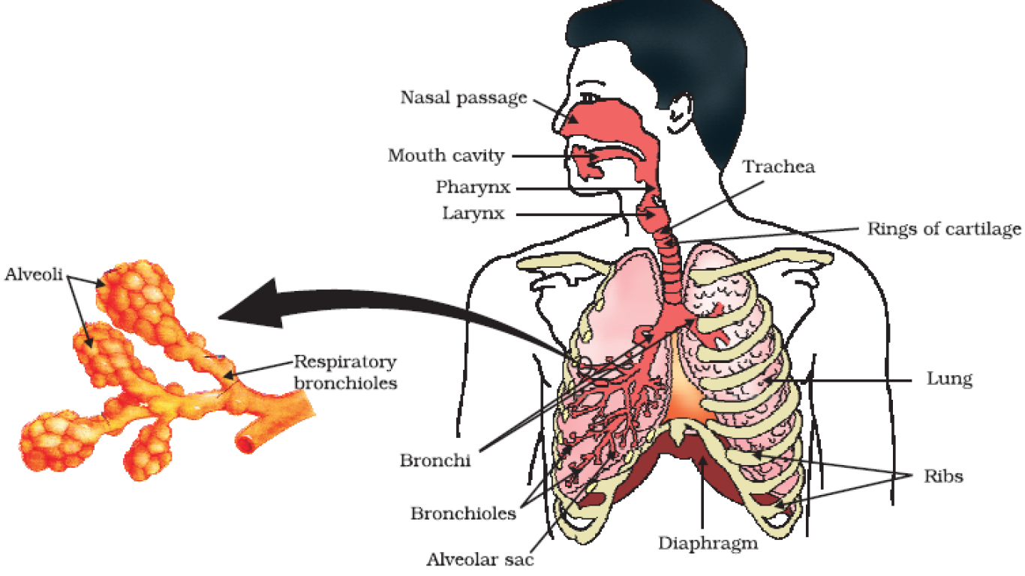 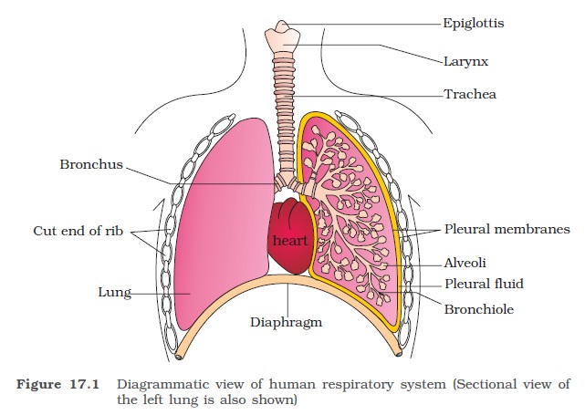

**Pathway of air in human respiratory system**



**Exchange of respiratory gases at alveoli**

* **O2 present in alveolar blood vessels is then transported to various cells of the body.**
* **Hemoglobin in red blood cell is majorly responsible for transportation of carbon dioxide and oxygen.**

**Transportation**

* **Multicellular organisms require regular supply of food, water, and oxygen.**
* **Circulatory system in animals perform the transport of nutrients, oxygen, hormones, wastes,e etc.**
* **In multicellular plants, there are two main conducting tissues namely xylem and phloem which help in transportation of water, food, organic materials, phytohormones.**
* **Xylem carries water and minerals from the roots to other parts of the plant.**
* **Phloem carries product of photosynthesis from leaves to the other parts of the plant.**
* **Translocation is the process of transporting of food from leaves to other parts of plant.**



**Cardiac Cycle**

* **Cardiac cycle is the rhythmic contraction and dilation of different parts of heart in one heart beat i.e. one complete contraction (systole) and relaxation (diastole) of heart.**
* **Average human heart beat = 72 times per minute.**
* **Heart beat is measured by stethoscope.**
* **Blood pressure is pressure exerted by blood on the wall of blood vessel.**
* **Blood pressure may be systolic pressure or diastolic pressure.**
* **Systolic pressure is the maximum pressure at which blood flows during contraction of heart (120 mmHg).**
* **Diastolic pressure is the maximum pressure at which blood flows during relaxation of heart (80 mmHg).**
* **Sphygmomanometer is the instrument used for measuring blood pressure.**

|  |  |
| --- | --- |
|  | **Figure Sectional view of human heart**  **Four chambered muscular organ** |
| **Figure Schematic representation of transport and exchange of oxygen and carbon dioxide** |  |

**Excretion as a life process**

***(Excretion is the process of removing of waste products from living body*)**

**Excretion in plants**

**Plants use different strategies for excretion unlike human and other animals as follows;**

* + - * + **Excess amount of Oxygen and Carbon dioxide diffuse out through stomata.**
        + **Excess water is removed by transpiration.**
        + **Waste products stored in leaves are excreted by falling leaves.**
        + **Shedding old and dead parts of plant.**
        + **Excrete wastes in the form of raisins and gums.**
        + **Excrete some waste substances into the soil.**

**Figure Diagrammatic representation of Human Excretory System**



**The excretory system consists of:**

* + - **a pair of kidneys,**
    - **a pair of ureters,**
    - **a urinary bladder, and**
    - **a urethra.**

**Figure: A diagrammatic representation of a nephron**



**Major functions of nephron/Kidney**

* **Excretion of nitrogenous wastes such as urea and uric acid.**
* **Reabsorption of water and electrolytes (HCO3, Na+, NH3,H+, K+).**
* **Maintenance of pH and ionic balance of the body fluids**
* **Maintenance of salt and water balance of body (osmoregulation).**

**Disorders Of the Excretory System**

* **Uremia (*accumulation of urea in blood due to malfunctioning of kidney*)**
* **Kidney/renal failure**
* **Renal calculi (*Stone or insoluble mass of crystallised salts like oxalates formed within the kidney*)**

**Hemodialysis Machine and Hemodialysis (*treatment for uremia/renal failure patient*)**



**The process of removing of nitrogenous wastes in blood through artificial kidney (hemodialysis machine) is called dialysis.**

* The unit contains a coiled cellophane tube surrounded by a dialysing fluid having the same composition as that of plasma except the nitrogenous wastes.
* The porous cellophane membrane of the tube allows the passage of molecules based on concentration gradient.
* Blood drained from an artery of patient is pumped into a dialysing unit after adding an anticoagulant like heparin.
* As nitrogenous wastes are absent in the dialysing fluid, these waste substances freely move out, thereby clearing the blood.
* The cleared blood is pumped back to the body through a vein after adding anti-heparin to it.
* The process of removing of nitrogenous wastes in blood through artificial kidney (hemodialysis machine) is called dialysis.

**Table: Role of Other Organs In Excretion**

